AMENDMENT TO THE DECLARATION OF
RESTRICTIVE COVENANTS

OF
POLO FARMS SUBDIVISION
THIS AMENDMENT TO THE DECLARATION OF RESTRICTIVE COVENANTS OF POLO FARMS SUBDIVISION is made of this 18 day of January 1990, by Equestrian Properties Limited Partnership hereinafter referred to as "Declarant", and Rita A. Collins (single), Carlton Jack Spivey (single), Joseph s. Rebo (single), John Douglas Martin (single), Archie Dean Gregory and wife, Julie L. Gregory, Edward F. Boylan and Dana C. Ratcliff, and Frank B. Bobbitt, III and wife, Sandra B. Bobbitt (all of whom are collectively referred to hereinafter as "Lot Owners"), and any and all persons, firms, or corporations hereafter acquiring any of the within described property or any of the property hereafter made subject to the Restrictive Covenants as hereby amended.
WITNESSETH:
WHEREAS, Declarant is the owner of certain property in Guilford County, North Carolina, known as POLO FARMS, Phases I and II, more particularly described by plats thereof recorded in the following Plat Books and Pages: Plat Book 94 at pages 97, 90 and 100 and Plat Book 95 at Pages 115, 116, and 117, in the Office of the Register of Deeds for Guilford County, to which recorded plats reference is hereby made for more complete descriptions;
WHEREAS, Declarant has heretofore established a general plan of development for POLO FARMS as set out in the Restrictive Covenants for Phases I and II of POLO FARMS as recorded in the Guilford County Public Registry in Book 37 65 at page 7 25 (the "Restrictions") and the Declaration of Covenants, Conditions and Restrictions of Polo Farms as corrected and recorded in the Guilford County Public Registry in Book 377 0 at page 2038 (the "Declaration");
WHEREAS, Declarant has decided that the requirement in the Restrictions that the first floor of any house must have a minimum of 1600 square feet is an unreasonable requirement and may adversely affect the visual effect of multi-story houses, and based thereon desires to amend the Restrictions to delete this requirement;
WHEREAS, Rita A. Collins is the owner of Lot 14 of Polo Farms, Section 1, as shown on a map thereof recorded in Plat Book
94 at Page 98;
WHEREAS, Carlton Jack Spivey is the owner of Lot 22 of Polo Farms, Section 2, as shown on a map thereof recorded in Plat Book
95 at Page 115;
WSM/January 18, 1990

North Carolina - Guilford County
The certificate (s) of 432657
RECORDED
WHEREAS, Joseph S. Rebo is the owner of Lot 59 of Polo Farms, Section 2, as shown on a map thereof recorded in Plat Book 95 at Page 116;
WHEREAS, John Douglas Martin is the owner of Lot 49 of Polo Farms, Section 2, as shown on a map thereof recorded in Plat Book 95 at Page 117;
WHEREAS, Archie Dean Gregory and wife, Julie L.Gregory, are the owners of Lot 32 of Polo Farms, Section 2, as shown on a map thereof recorded in Plat Book 95 at Page 117;
WHEREAS, Edward F. Boylan and Dana C. Ratcliff are the owner of Lot 27 8 of Polo Farms, Section 1, as shown on a map thereof recorded in Plat Book 94 at Page 100;
WHEREAS, Frank B. Bobbitt, III and wife, Sandra B. Bobbitt, are the owners of Lot 8 of Polo Farms, Section 1, as shown on a map thereof recorded in Plat Book 94 at Page 100; and
WHEREAS, all of the Lot Owners have agreed to the amendment of the Restrictions for the purposes aforesaid.
NOW, THEREFORE, in accordance with the recitals which by this reference are made a substantive part hereof, Declarant declares that all of the property described on said recorded plats herein above described is and shall be subject to the Restrictive Covenants as hereby amended and shall be held, sold and conveyed subject to the following Restrictive Covenants as hereby amended and, as hereby amended, the Restrictive Covenants shall burden and run with the real property known as POLO FARMS, PHASES I and II and all of the Lots therein as shown on the aforesaid record plats, and the Restrictive Covenants as hereby amended shall be binding on all parties now or hereafter owning any of the said real property and their respective heirs, successors and assigns, having any right, title or interest in the properties now or hereafter subjected to the Restrictive Covenants, as hereby amended, and the Declaration or any part thereof, and shall inure to the benefit and burden the property of each owner thereof and their respective heirs, successors and assigns.
1. Paragraph 2 of the Restrictions is amended by inserting a period after the word "stories" on line five thereof and deleting the remainder of the sentence. As amended, Paragraph 2 reads as follows:
“2. Each single family dwelling shall have an enclosed, heated living area of the main structure, exclusive of open porches, garages, and other unheated spaces, of not less than two thousand eight hundred (2,800)
WSM/January 18, 1990
square feet regardless of the number of stories. All residential dwellings must have a garage or attached carport accommodating at least two vehicles under roof. The design, location, and construction of all improvements on each lot (regardless of when such improvements are made) and the landscaping of each lot must be approved in advance by the Architectural Control Committee (the "Committee") which Committee is established pursuant to the Declaration."
2. As hereby amended, the parties ratify and confirm the Restrictions as if fully set out herein.
THE RESTRICTIONS AS AMENDED RUN WITH THE LAND
The Restrictive Covenants, as hereby amended, and the Declaration of Covenants, Conditions and Restrictions for Polo Farms Subdivision compose the general plan of development for the property herein described and run with the land and shall benefit and be binding on all parties and persons (and their respective heirs, representatives, successors and assigns) claiming title to any of the Property herein described for a period of thirty (30) years from the date the Restrictive Covenants were originally recorded, after which time said covenants shall be automatically extended for successive periods of ten (10) years, unless an instrument signed by a seventy-five (75%) percent majority of the then owners of the Lots has been recorded agreeing to change said covenants in whole or in part.
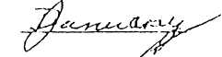
IN WITNESS WHEREOF, the Declarant has caused this Declaration to be duly executed this 18th day of
, 1990.
EQUESTRIAN PROPERTIES LIMITED
PARTNERSHIP (SEAL)

[AFFIX CORPORATE SEAL] Attest:
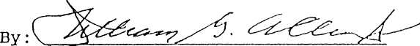
Martha Fleckenstein, Secretary
BY: PERFORMANCE INVESTMENTS, INC., General Partner
William G. Allen, Jr., Vice President

(SEAL)
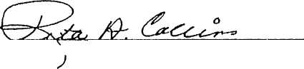
Rita A. Collins - Lot 14

Carlton Jack Spivey - Lor 22
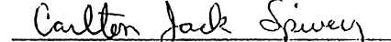
tr
(SEAL)

WSM/January 18, 1990
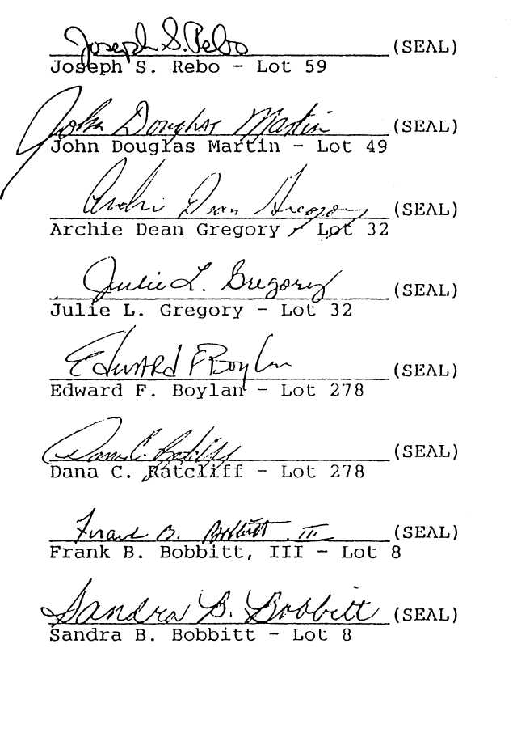
WSM/January 18, 1990
STATE OF NORTH CAROLINA COUNTY OF MECKLENBURG
I, a Notary Public of the County and State aforesaid, certify that William G. Allen, Jr.,. personally came before me this day and acknowledged that he is the Vice President of PERFORMANCE INVESTMENTS, INC., a North Carolina corporation, that the said corporation is the general partner of EQUESTRIAN PROPERTIES LIMITED PARTNERSHIP, and that by authority duly given and as the act and deed of the said corporation in its capacity as the general partner of EQUESTRIAN PROPERTIES LIMITED PARTNERSHIP, the foregoing instrument was signed in its name by him as its Vice President, sealed with its corporate seal and attested by Martha Fleckenstein as its Secretary-

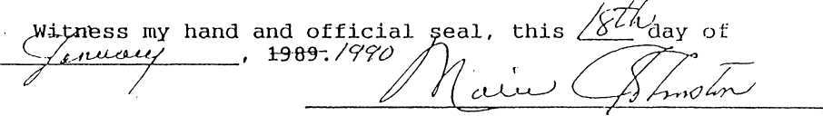
Notary Public
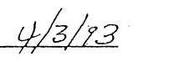
My Commission Expires: 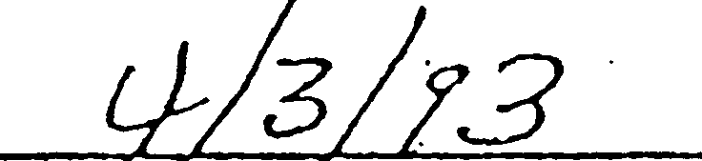
STATE OF NORTH CAROLINA COUNTY OF GUILFORD
I, a Notary Public of the County and State aforesaid,
certify that Rita A. Collins personally came before me this day
and, being duly sworn, acknowledged the due execution of the
foregoing instrument.

Notary Public
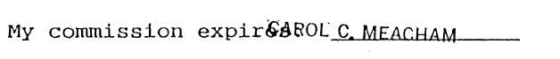
NOTARY PUBLIC
GUILFORD COUNTY, NC
Aty Commission Expires 1-14.95,

WSM/January 18, 1990
STATE OF NORTH CAROLINA
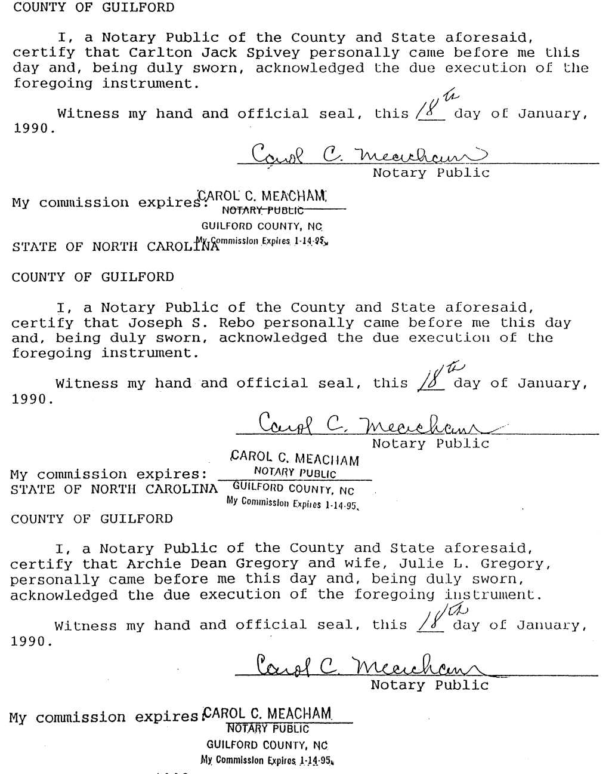

WSM/January 18, 1990
